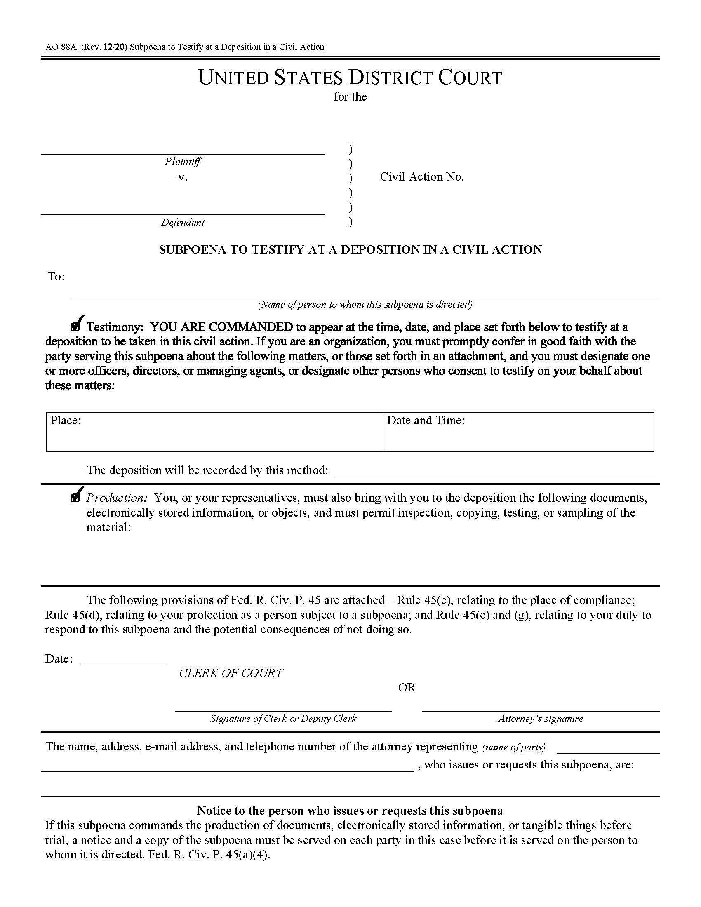
California
<< Matter.CustomField.County >>

<< Matter.CustomField.PlaintiffsNameShort >>

<< Matter.CustomField.CaseNumber >>
<< Matter.CustomField.DefendantsNameShort >>

<< Matter.CustomField.ServicingDealership1 >>'s Person Most Qualified,
<< Matter.CustomField.ServicingDealership1Loc >>

<< Matter.CustomField.ServicingDealership1 >>
<< Matter.CustomField.ServicingDealership1Loc >>
[REMOTE]

Remote Video Feed Per FRCP Rule 30 (b) 4

See Exhibit A attached to the Notice of Deposition

<< Date.Verbose >>

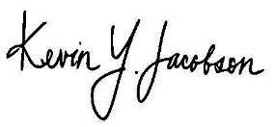

<< Matter.CustomField.PlaintiffsNameShort >>
Kevin Jacobson, Esq., Quill & Arrow LLP, 10880 Wilshire Blvd., Suite 1600, Los Angeles, CA 90024; kjacobson@quillarrowlaw.com, (310) 933-4271

